**Industrial Interaction Report on**



**Application For Data management of Electrical appliances**



**Submitted in partial fulfilment of the requirement for the award of the degree of**

**BACHELOR OF TECHNOLOGY**

**IN**

**COMPUTER SCIENCE & ENGINEERING**

**Submitted by:**

**Student Name University Roll No.**

**Ayush Dhiman** **2016689**

**Department of Computer Science and Engineering**

**Graphic Era (Deemed to be University)**

**Dehradun, Uttarakhand**

**2023-24**

**CANDIDATE’S DECLARATION**

I hereby certify that the work which is being presented in the Industrial Interaction report entitled **“Application For Data Management of Electrical Appliances”** in partial fulfillment of the requirements for the award of the Degree of Bachelor of Technology in Computer Science and Engineering in the Department of Computer Science and Engineering of the Graphic Era (Deemed to be University), Dehradun shall be carried out by the undersigned under the supervision of **Mr Rajeev Kharkwal**, Department of IT, UPCL, V.C.V.G.S, Dehradun.

Ayush Dhiman

2016689

CSE

**Table of Contents**

|  |  |  |
| --- | --- | --- |
| **Chapter No.** | **Description** | **Page No.** |
| Chapter 1 | Introduction of UPCL | 4 |
| Chapter 2 | SCADA | 5-6 |
| Chapter 3 | Problem Statement | 7 |
| Chapter 4 | Technologies used | 7-12 |
| Chapter 5 | Application view | 13 |
|  |  |  |

**Chapter 1 INTRODUCTION**

**ORGANISATION PROFILE:**

UPCL (Uttarakhand Power Corporation Ltd) is the company responsible for electricity transmission and distribution within the Indian state of Uttarakhand. The incumbent chairman is Smt. Radha Raturi.[3] As the sole distributor of power in Uttarakhand, it manages Uttarakhand's 2600 MW daily demand.

UPCL has one main station and under that comes some SUB stations at different places in the district, these Sub-stations are responsible for the electricity supply of that region. The main station can regulate all the sub-stations. There is one SCADA (SUPERVISORY CONTROL AND DATA ACQUISITION) system that allows the main station to connect through substations digitally and hence experienced Engineers are required for the proper flow of electricity from the main department to other substations.

**History of UPCL**

The history of Uttarakhand Power Corporation Limited (UPCL) can be traced back to erstwhile U.P. State Electricity Board (UPSEB). The erstwhile U.P. State Electricity Board was trifurcated pursuant to the enactment of U.P. Electricity Reforms Act, 1999. U.P. State Electricity Reforms Transfer Scheme, 2000 was promulgated for execution of the trifurcation of erstwhile UPSEB into U.P. Power Corporation Limited (UPPCL), U.P. Jal Vidyut Nigam Limited (UPJVNL) and U.P.Rajya Vidyut Utpadan Nigam Limited.

**IT DEPARTMENT, UPCL**

This department aims to control and supervise the data regarding activites. as we all know with the advancement in technology, all the sectors are growing with the digital view so as UPCL. So to handle data and supervise that data we have this different department Called as data centre.

The IT department has three major areas of concern, which include governance of the company's technological systems, maintenance of the infrastructure and functionality of the systems overall. Beyond that, professionals within the IT department work internally on computer software and hardware in many ways that allow a business to be successful.

RESPONSIBILITIES OF IT DEPARTMENT IN UPCL

* Maintain computer infrastructures of the company
* Assist new users with computer and software issues Train employees on new systems
* Perform software updates
* Renew licenses and other legal documents Monitor ongoing contracts with suppliers .
* Complete statutory forms
* Ensure compliance with quality standards

**Chapter 2 INTRODUCTION TO SCADA**

**SUPERVISORY CONTROL AND DATA ACQUISITION**

A SCADA system is a common industrial process automation system which is used to collect data from instruments and sensors located at remote sites and to transmit data at a central site for either monitoring or controlling purpose.

The collected data from sensors and instruments is usually viewed on one or more SCADA host computers that relocated at the central site.

Based on the information received from the remote stations, automated or operator-driven supervisory commands can be pushed to remote station control devices, which are often referred to as field devices.

**SCADA IMPLEMENTATION**

> Data acquisition

Data acquisition refers to acquiring, or collecting, data. This data is collected in the form of measured analog current or voltage values or the open or closed status of contact points

> Supervision:

Computer processes and supervise, or monitor, the conditions and status of the power system using this acquired data. Operators and engineers monitor the information remotely on computer displays and graphical wall displays or locally, at the device, on front-panel displays and laptop computers.

>Control:

Control refers to sending command messages to a device to operate the power-system devices.

**Pictorial View Of SCADA System**

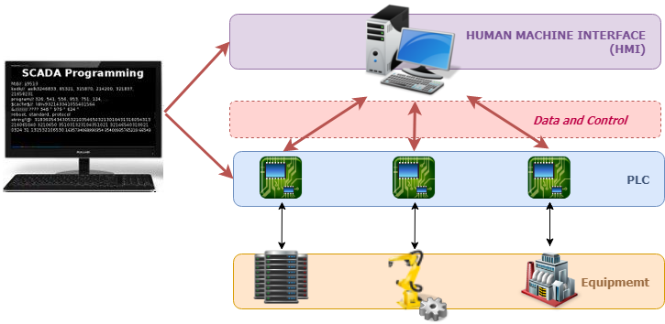

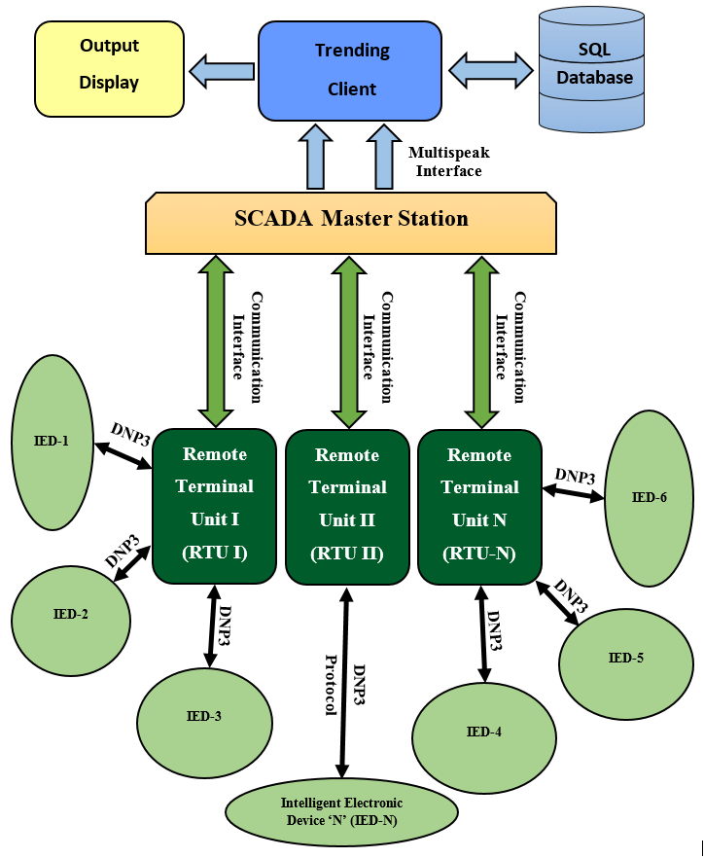

**Chapter 3 Problem Statement:**

There are various computer appliances in UPCL. Computer systems, CPU, and other electrical setups whose records must be there so that we have records of all the working, nonworking, warranty status, and other records of electrical appliances kept in place. There are several issues with the management of the data in traditional manner since , data privacy is compromised , data duplicity is a huge issue , data may also get lost.

Our project goal is to make a web application, that stores all the data regarding the electrical applications. The web application will have a centralized database of all the electrical appliances, their status like working, non-working, in use, not in use, if they went for repair then given to which company for repair, the date at which they were given, company employee name, etc. With the help of the web application, the problem of data loss and data duplicity will be sorted and we will have a convenient way of managing all the data regarding the electrical appliances.

**Chapter 4 Technologies Used:**

**Web Development**

Web development refers to the creating, building, and maintaining of websites. It includes aspects such as web design, web publishing, web programming, and database management. It is the creation of an application that works over the internet i.e. websites.

The word Web Development is made up of two words, that is:

Web: It refers to websites, web pages or anything that works over the internet.

Development: It refers to building the application from scratch.

Web Development can be classified into two ways:

* Frontend Development
* Backend Development

**Frontend Development**

The part of a website where the user interacts directly is termed as front end. It is also referred to as the ‘client side’ of the application.

Popular Frontend Technologies

HTML: HTML stands for HyperText Markup Language. It is used to design the front end portion of web pages using markup language. It acts as a skeleton for a website since it is used to make the structure of a website.

CSS: Cascading Style Sheets fondly referred to as CSS is a simply designed language intended to simplify the process of making web pages presentable. It is used to style our website.

JavaScript: JavaScript is a scripting language used to provide a dynamic behavior to our website.

Bootstrap: Bootstrap is a free and open-source tool collection for creating responsive websites and web applications. It is the most popular CSS framework for developing responsive, mobile-first websites. Nowadays, the websites are perfect for all browsers (IE, Firefox, and Chrome) and for all sizes of screens (Desktop, Tablets, Phablets, and Phones).

**Backend Development**

Backend is the server side of a website. It is part of the website that users cannot see and interact with. It is the portion of software that does not come in direct contact with the users. It is used to store and arrange data.

Popular Backend Technologies

PHP: PHP is a server-side scripting language designed specifically for web development.

Java: Java is one of the most popular and widely used programming languages. It is highly scalable.

Python: Python is a programming language that lets you work quickly and integrate systems more efficiently.

Node.js: Node.js is an open source and cross-platform runtime environment for executing JavaScript code outside a browser.

**PROGRAMMING LANGUAGES USED**

**HTML**

HTML stands for HyperText Markup Language. It is used to design the web pages. With the help of HTML, you can create a complete website structure. HTML is the combination of Hypertext and Markup language. Hypertext defines the link between the web pages and markup language defines the text document within the tag that define the structure of web pages.

HTML is used to create the structure of web pages and website that are displayed on the Internet. HTML basically contains Tags and Attributes that are used to design the web pages. Also, we can link multiple pages using Hyperlinks.

HTML Basic Structure of Web Page

The basic structure of an HTML page is laid out below. It contains the essential building-block elements (i.e. doctype declaration, HTML, head, title, and body elements) upon which all web pages are created.

HTML Page Structure

HTML Basic Tags

<DOCTYPE! html> – A doctype or document type declaration is an instruction that tells the web browser about the markup language in which the current page is written. It is not an element or tag. The doctype declaration is not case-sensitive.

<html> – This tag is used to define the root element of HTML document. This tag tells the browser that it is an HTML document. It is the second outer container element that contains all other elements within it.

<head> – This tag is used to define the head portion of the HTML document that contains information related to the document. Elements within the head tag are not visible on the front-end of a webpage.

<body> – The body tag is used to enclose all the visible content of a webpage. In other words, the body content is what the browser will show on the front end.

**CSS (Cascading Style Sheets):**

Cascading Style Sheets (CSS) is the technology that web developers use to style and format web pages. While HTML provides the structure and content of a web page, CSS defines how that content should appear visually. CSS is responsible for layout, typography, colors, and overall aesthetics.

Key concepts and capabilities of CSS include:

1. Selectors: CSS uses selectors to target HTML elements for styling. Selectors can be based on element types, classes, IDs, and other attributes.

2. Properties and Values: Properties define the aspects of an element to be styled, such as font-size, color, margin, and padding. Values are assigned to properties to determine the specific style.

3. Box Model: CSS employs the box model, which defines how elements are displayed as rectangular boxes with content, padding, borders, and margins. Understanding the box model is crucial for creating layouts.

4. Layout Techniques: CSS can control the layout of a web page, allowing developers to create multi-column designs, flexbox layouts, and grid-based structures for responsive design.

5. Media Queries: Media queries enable responsive design by applying different styles based on the device's screen size or characteristics.

6. Transitions and Animations: CSS can add dynamic effects to web pages, including smooth transitions, animations, and keyframe animations.

7. *Flexibility and Inheritance:* CSS properties can cascade or inherit values from parent elements, allowing for consistent styles and efficient code.

8. *External Stylesheets:* CSS styles can be placed in separate external files, which promotes code organization and reuse.

CSS is often combined with HTML and JavaScript to create modern, feature-rich web applications. CSS frameworks like Bootstrap and pre-processors like SASS further enhance the development process by providing pre-designed styles and more advanced features.

**JavaScript:**

JavaScript, often abbreviated as JS, is a versatile and dynamic programming language that is essential for web development. It adds interactivity and dynamic behavior to websites, making them responsive and engaging for users. JavaScript is primarily used on the client side, running within web browsers, but it can also be employed on the server side with platforms like Node.js.

JavaScript's power lies in its ability to manipulate the Document Object Model (DOM), a structured representation of a web page's content. This allows developers to create dynamic web experiences by modifying page elements, responding to user interactions, and fetching data from servers without requiring a full page reload.

Key features of JavaScript include:

1. Variables and Data Types: JavaScript supports variables for storing data, including numbers, strings, booleans, and more. It's a dynamically typed language, meaning you don't need to declare variable types explicitly.

2. Functions: Functions are blocks of code that can be defined, reused, and passed as arguments. They are crucial for organizing and encapsulating logic.

3. Conditional Statements: JavaScript offers if statements, switch statements, and ternary operators for making decisions in code.

4. Loops: For and while loops enable repetitive execution of code.

5.Events: JavaScript can respond to events such as clicks, keypresses, and form submissions, enabling user interactions.

6.Asynchronous Programming: JavaScript's asynchronous capabilities, through features like callbacks and Promises, allow it to handle tasks like fetching data from servers without blocking the user interface.

JavaScript is at the heart of modern web development, and its ecosystem includes a vast collection of libraries and frameworks, such as React, Angular, and Vue.js, which simplify and accelerate the development of complex web applications. These libraries provide pre-built components and architectures for creating user interfaces, handling state management, and routing.

**Node Js**

Node.js is a runtime environment that allows server-side JavaScript development. It is built on the V8 JavaScript engine, which is the same engine that powers Google Chrome. Node.js enables developers to use JavaScript on both the client and server sides, offering a unified and full-stack approach to web development.

Key characteristics and capabilities of Node.js include:

1.Non-Blocking, Event-Driven Architecture: Node.js follows an event-driven, non-blocking I/O model, making it highly efficient for handling asynchronous operations. This architecture allows Node.js to serve a large number of concurrent connections without blocking the execution of other tasks, which is crucial for real-time applications and high-performance servers.

2. Npm (Node Package Manager): Npm is a package manager that comes with Node.js, providing access to a vast ecosystem of open-source libraries and modules. Developers can easily incorporate third-party packages to enhance their applications.

3. CommonJS Modules: Node.js uses the CommonJS module system, which allows developers to structure code into reusable modules, making it easier to maintain and scale projects.

4. Server-Side Development: Node.js is well-suited for server-side development, allowing developers to create web servers, APIs, and real-time applications. Popular frameworks like Express.js provide additional tools and features for building web applications.

5. File System Access: Node.js provides APIs for file system operations, making it suitable for tasks like reading and writing files on the server.

6. Cross-Platform Compatibility: Node.js is cross-platform, meaning it can run on various operating systems, making it a versatile choice for server-side development.

7. Community and Ecosystem: Node.js has a thriving community and an extensive ecosystem. This means that developers can find libraries, modules, and resources for almost any task or requirement.

Node.js is commonly used in scenarios where real-time communication is essential, such as chat applications, online gaming, and collaborative tools. It's also ideal for building APIs that serve data to front-end applications. Additionally, Node.js can be used in conjunction with various databases, both relational and NoSQL, to create dynamic and data-driven web applications.

**MongoDB:**

MongoDB is a leading NoSQL database system designed for flexibility, scalability, and efficient data management. It is often employed in web development to store, retrieve, and manage vast amounts of data in a variety of applications, including content management systems, e-commerce platforms, and real-time analytics.

Key features of MongoDB include:

1. Document-Oriented: MongoDB stores data in BSON (Binary JSON) documents, which are self-descriptive and flexible. This schema-less approach allows developers to work with data without the constraints of a predefined schema.

2. Scalability: MongoDB is horizontally scalable, which means it can handle large amounts of data and high traffic by distributing data across multiple servers or nodes.

3. Replication: MongoDB supports data replication, ensuring high availability and data redundancy. Replication provides fault tolerance in case of server failures.

4. Querying: MongoDB's powerful query language enables developers to find, filter, and manipulate data using a rich set of query operators.

5. Indexes: Indexes can be created to speed up data retrieval, making queries more efficient.

6. Aggregation: MongoDB offers a versatile aggregation framework for performing complex data transformations and analytics.

7. Geospatial Queries: MongoDB supports geospatial data and allows for location-based queries.

**Chapter 5 Application View**

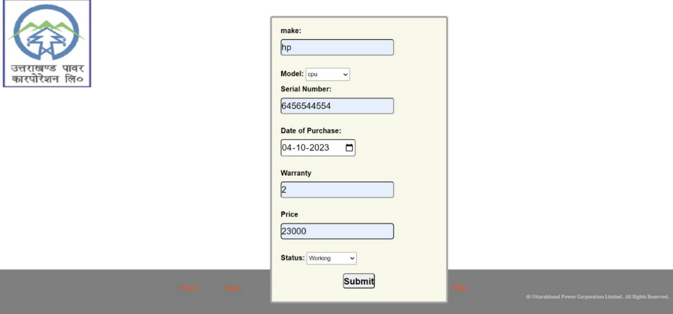

**REFERENCES**

-HTML standard itself: [1] "HTML - Hypertext Markup Language," W3C Recommendation, World Wide Web Consortium (W3C), [Online]. Available: https://www.w3.org/TR/html52/. [Accessed: Date].

- JavaScript: [2] "JavaScript," Mozilla Developer Network (MDN), [Online]. Available: https://developer.mozilla.org/en-US/docs/Web/JavaScript. [Accessed: Date].

- CSS: [3] "CSS: Cascading Style Sheets," W3C Recommendation, World Wide Web Consortium (W3C), [Online]. Available: https://www.w3.org/Style/CSS/. [Accessed: Date].

-MongoDB: [4] "MongoDB," MongoDB, Inc., [Online]. Available: https://www.mongodb.com/. [Accessed: Date].

- INode.js: [5] "Node.js," Node.js Foundation, [Online]. Available: https://nodejs.org/. [Accessed: Date].